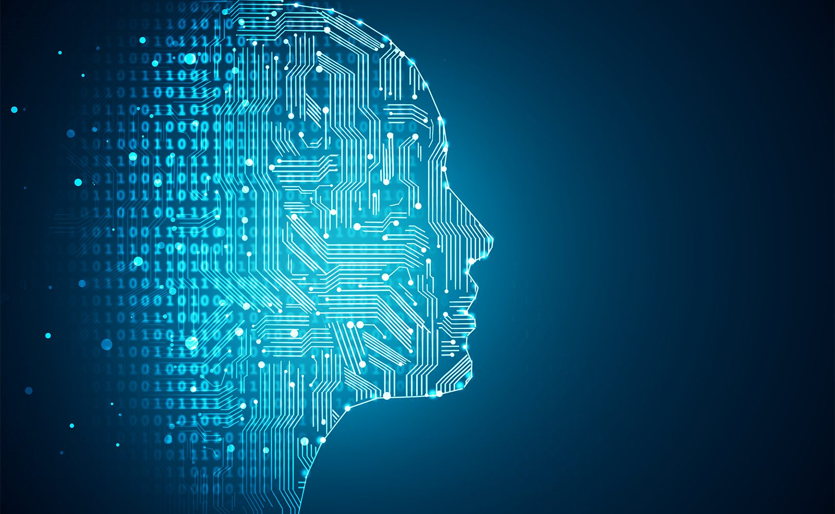

|  |
| --- |
| COVID-19 CASES PREDICTION  (USING MACHINE LEARNING) |
|  |
| ibm PROJECT  BY-ASUTOSH PATRA & ANIMESH SINGH  (LOVELY PROFESSIONAL UNIVERSITY) |

COVID-19 CASES PREDICTION

|  |
| --- |
| Why this? Prediction of the dynamics of new SARS-CoV-2 infections during the current COVID-19 pandemic is critical for public health planning of efficient health care allocation and monitoring the effects of policy interventions. We describe a new approach that forecasts the number of incident cases in the near future given past occurrences using only a small number of assumptions.  Method of approach to solve?  Our approach to forecasting future COVID-19 cases involves:   1. Gathering dataset related to this problem (From Kaggle – <https://www.kaggle.com/sudalairajkumar/covid19-in-india>). 2. Visualizing the datasets with the help of graphs, and figures. 3. Use these datasets to train the machine learning model i.e., Linear Regression. 4. Predict the result of future. |
| *Library used:*   * Pandas * Matplotlib * Seaborn * Datetime * Numpy * Sk_learn(i.e., sklearn.linear_model & sklearn.metrics) |
| How to install packages?  (Make sure you have installed python in your system)  Open command prompt and then use the command given below for installing the packages-   1. Pandas:   pip install pandas   1. Matplotlib:   pip install matplotlib   1. Seaborn:   pip install seaborn   1. Datetime:   pip install DateTime   1. Numpy:   pip install numpy   1. Sk_learn:   pip install scikit-learn  Result  We apply our method to predicting the number of new COVID-19 cases in a single state in India. Our method produces reasonably accurate results when the effective reproduction number is distributed similarly in the future as in the past. Large deviations from the predicted results can imply that a change in policy or some other factors have occurred that have dramatically altered the disease transmission over time.  Conclusion  **We presented a modelling approach that we believe can be easily adopted by others, and immediately useful for future planning in local or state.** |